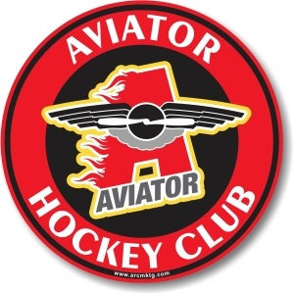
Chris Kienzle, PeeWee Major 2005, Head Coach
Chris grew up in locally in Brooklyn, NY. He has been involved in the Aviator Hockey program since 2007 and he has been a part of the Travel Organization since its inception when it was exclusively “A” Level. He has coached all age levels Mite-Midget although he is currently focused on Squirt and PeeWee ages. Chris also is a registered USA Hockey official and has officiated Mite-Midget games as well across all levels of play.
Playing Career
- Xaverian High School, CHSHL (2004-2007)
- GNY Stars, Midget Major, LIAHL (2006-2007)
- Metro Fighting Moose, Junior C, CHA (2008-2009) National Championship Appearance
- Metro Jets Hockey Club, Tier Three Junior, NA3HL (2009-2010)
Coaching Career
- Assistant Coach, Mite Major A (2008-2009) LIAHL King of the Hill Champion
- Assistant Coach, Squirt Major A (2010-2011) Tier Three LIAHL Champions
- Head Coach, Squirt Major AA (2011-2012) Tier Two LIAHL Champions, Silver Stick Regional Champions
- Head Coach, Squirt Major AA (2012-2013) Tier Two LIAHL Champions
- Head Coach, Squirt Major AA (2013-2014)
- Head Coach, Squirt Major AA (2014-2015)
- Head Coach, Squirt Major AAA (2015-2016) Achieved playoff berth in first year at AAA.
- Head Coach, PW Minor AAA (2016-2017) Won Kennedy Memorial Tournament in RI.
Philosophy
Chris has a passion for hockey because of the disciplines it teaches. Hard work, dedication, discipline and team first attitude are all qualities that every player needs to possess to be successful in the sport. Without them, nothing can be accomplished. These same ideals are vital attributes outside of the hockey world as well so the ability to teach young players and instill them is a great opportunity to have in molding the future.

